Project Statement of Work

|  |  |
| --- | --- |
| **Team Members:**  **Daniel Nikolic, Ahmad Alramahi, Hayden Sellars, Rithwik Gokhale** |  |
| **Team Name:** | **Cybot Eats** |
| **Lab Section: C** |  |
| **TA Approval:** | Bryton |

Refer to the ESI Project Requirements document before completing this Statement of Work (SOW). Teams should complete and submit this SOW form, which represents several parts of a statement of work, including a plan for what you are doing and how. The SOW defines the scope of your project and the approach you are taking to deliver on the goals.

# Problem Statement

First, review and elaborate on the broad mission goals of your AV application using the memo your team wrote earlier. The mission goals and user needs establish the purpose of the project and why you are working on it. Now you should translate these into a more detailed problem statement that provides a clear description of the context for the problem, an explanation of user needs that will be addressed, and an outline of your proposed technical approach to solving the problem. In addition to writing a paragraph or two about the problem, you are to draw a one-page sketch illustrating your solution with a user context (big picture view). This should show the scope of your work in relation to one or more user needs.

The problem statement should provide a specific, concise, clear, and thorough description of the context for your mission goals. The statement must be understood and considered relevant by division managers. It should mention a specific user (or user group), their need(s), and their reason for having that need. The need and reason must be supported by your prior user research.

|  |
| --- |
| **Problem Statement:**  There is a need in the real world for cheap, fast, and safe delivery of pizza. Nothing that we have seen fulfills this, so we are going to utilize our roomba to demo how we could implement the efficient delivery of pizza in the real world. While we are not going to be making any hardware modifications to the roomba bot, this project is mainly designed to show that with a properly designed program, the microcontroller and the roomba bot can navigate through a maze (which simulates real life obstacles on roads and pavements) to reach the desired destination. Therefore, this project is designed to simulate the process of navigating through obstacles to arrive at a destination. The main user group this project is targeting is the general public. A majority of US population relies on home delivery of food. While this process is currently heavily human based, with advancements in automated technology and research with robots, this process can be semi-automated in the future where the robot moves with the user only controlling from the base. The main need for this development would be for the user to use software to navigate through obstacles present in real life. This project will simulate the above needs and requirements. |

# Design Approach

Next, consider your AV application in relation to the project requirements and the five categories by which it will be evaluated.

1. Functionality in relation to the AV application mission goals and user needs
2. Mapping of functional requirements to platform components and capabilities
3. Elements of the test field
4. Serious incident penalties
5. Feature bonuses

In this section, you will identify and describe how you will design your application for each of these categories.

In addition to completing the tables below, you are to draw a one-page sketch depicting a high-level technical system diagram of your proposed solution, such as a block diagram or dataflow diagram. This should show both hardware and software modules.

**The tables below are your initial proposal, and you may update these before your demonstration.**

## Functionality

Describe each of the basic functionalities required for the project in terms of your AV application. The functionality should be specific to the problem and user(s). Several functional statements are given in the example functional description for the Mars rover application in the Project Requirements document.

|  |  |
| --- | --- |
| **Basic Functionality** | **Mapping to AV Application** |
| Cybot Communication | Directions sent through wifi on Eclipse via a map made using JFrame. |
| Cybot Movement | The Cybot moving will be equivalent to a pizza delivery car moving down the street. |
| Object Detection | Objects will represents a slew of real life obstacles such as pedestrians or other cars. |
| Object Avoidance | Crashing into a pedestrian or car would be really bad so we want to avoid those. |
| Boundary Adherence | Its Boundary is the individual robot’s “delivery zone”, it doesn’t deliver outside of it. |
| Arrival at Destination | Its arrival is delivering the pizza or ordered food. |
| User Interface | The user interface would be our GUI via JFrame, you could tell the robot through the UI to head to specific designated zones such as the “pizza store” |
| Base Station Control | We would use the base station to tell the robot what we wanted it to do, like “go pick up pizza”, or “go deliver pizza.” |
| **Other Application Specific Functionality (may be novel features for bonus points)**  **Plays a happy chime upon arriving at destination and beginning journey.**  **We have implemented a graphical user interface using JPanels via java. This GUI will display a radar of scanned objects everytime a scan occurs and update these objects in a map relative to the bot’s position.**  **According to category 5 from the Project Requirements page we have letters a, c, and d ready for extra credit.** | |

## Mapping to Platform

Briefly describe how each of the basic platform components required for the project will be used in your AV application.

|  |  |
| --- | --- |
| **Basic Platform Components** | **Usage in AV Application** |
| Open Interface and iRobot Sensors | The iRobot’s sensors will detect obstacles on the road and locating the edges of the road. |
| Interrupts | We could utilize interrupts for the ping sensor, we could also utilize interrupts for the cliff and bump sensor. |
| ADC | The ADC will be used for the IR sensor which will be used with the ping sensor for object detection and object width detection. |
| Input Capture | Input Capture will be used in conjunction with interrupts for the ping sensor, we would set the input capture to edge time mode for usage with the Ping sensor. |
| PWM | We will set the timer to PWM for the ping sensor primarily |
| UART/WiFi | The UART plus wifi will be used for putty interfacing and commanding the CyBot on the go. |
| **Other Platform Components or Modes (may be novel features for bonus points)**  **The onboard speakers for the sound at delivery.**  **AV mapping and graphical user interface**  **Project requirements category 5: a, c, d** | |

## Elements of the Test Field

Briefly describe a test field in the context of the real application (e.g., Martian terrain, city streets, etc.). Then state what each of the basic objects and other elements required for the test field represent in terms of the AV application. Draw and attach a sketch of a possible simple test field for the lab.

|  |
| --- |
| **Test Field Description**  The test field for our iRobot will be the streets of town X(Ames?). The robot will receive directions for a customer to deliver pizza to. We will use the robot’s data to find the most efficient path of delivery. Our GUI and map will help the robot to avoid basic objects and stay within the streets edges. Basic objects could represent cars, pedestrian, construction, etc.  The sketch for this field can be found at the end of the document. |

|  |  |
| --- | --- |
| **Basic Objects and Other Elements** | **Mapping to AV Application Test Field** |
| Tall objects | Cars |
| Short objects | Pedestrians |
| Holes | Potholes or construction |
| Pillars | Street signs |
| Out of bounds | Street limits |
| Destination zone | Customer’s address |
| **Other Application Specific Elements (may be novel features for bonus points or incidents to avoid)**  Perhaps some lane lines to represent the lanes where vehicles can travel, made of tape. | |

## Serious Incidents to Avoid and/or Novel Features (Optional)

You may have identified novel features in the tables above. Enter them in the table below and propose possible bonus points if demonstrated successfully. In addition, describe any additional serious incidents that might happen in your test field for your AV application.

|  |  |
| --- | --- |
| **Novel Features**  Sound on Delivery  Graphical User Interface  AV application and detailed mapping of test field  Possible Controller Mapping | **Bonus Points**  2 bonus points  5 bonus points  10 bonus points  ? bonus points |

|  |  |
| --- | --- |
| **Serious Incidents**  Causing an accident | **Deductions**  -2 points |

## Sketches

Attach the following sketches to your submission.

* **Problem sketch**
* **Test field sketch**
* **Technical system sketch**

Problem sketch: The squares denote obstacles while the circle at the bottom represents the cyBot.

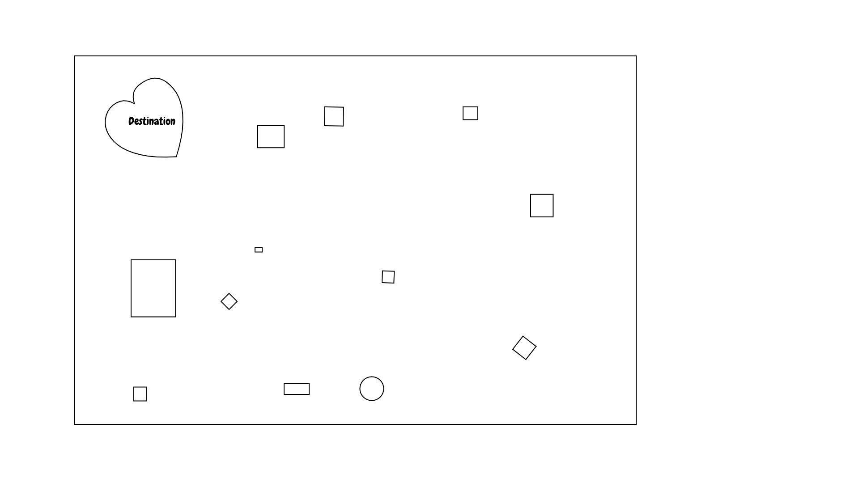

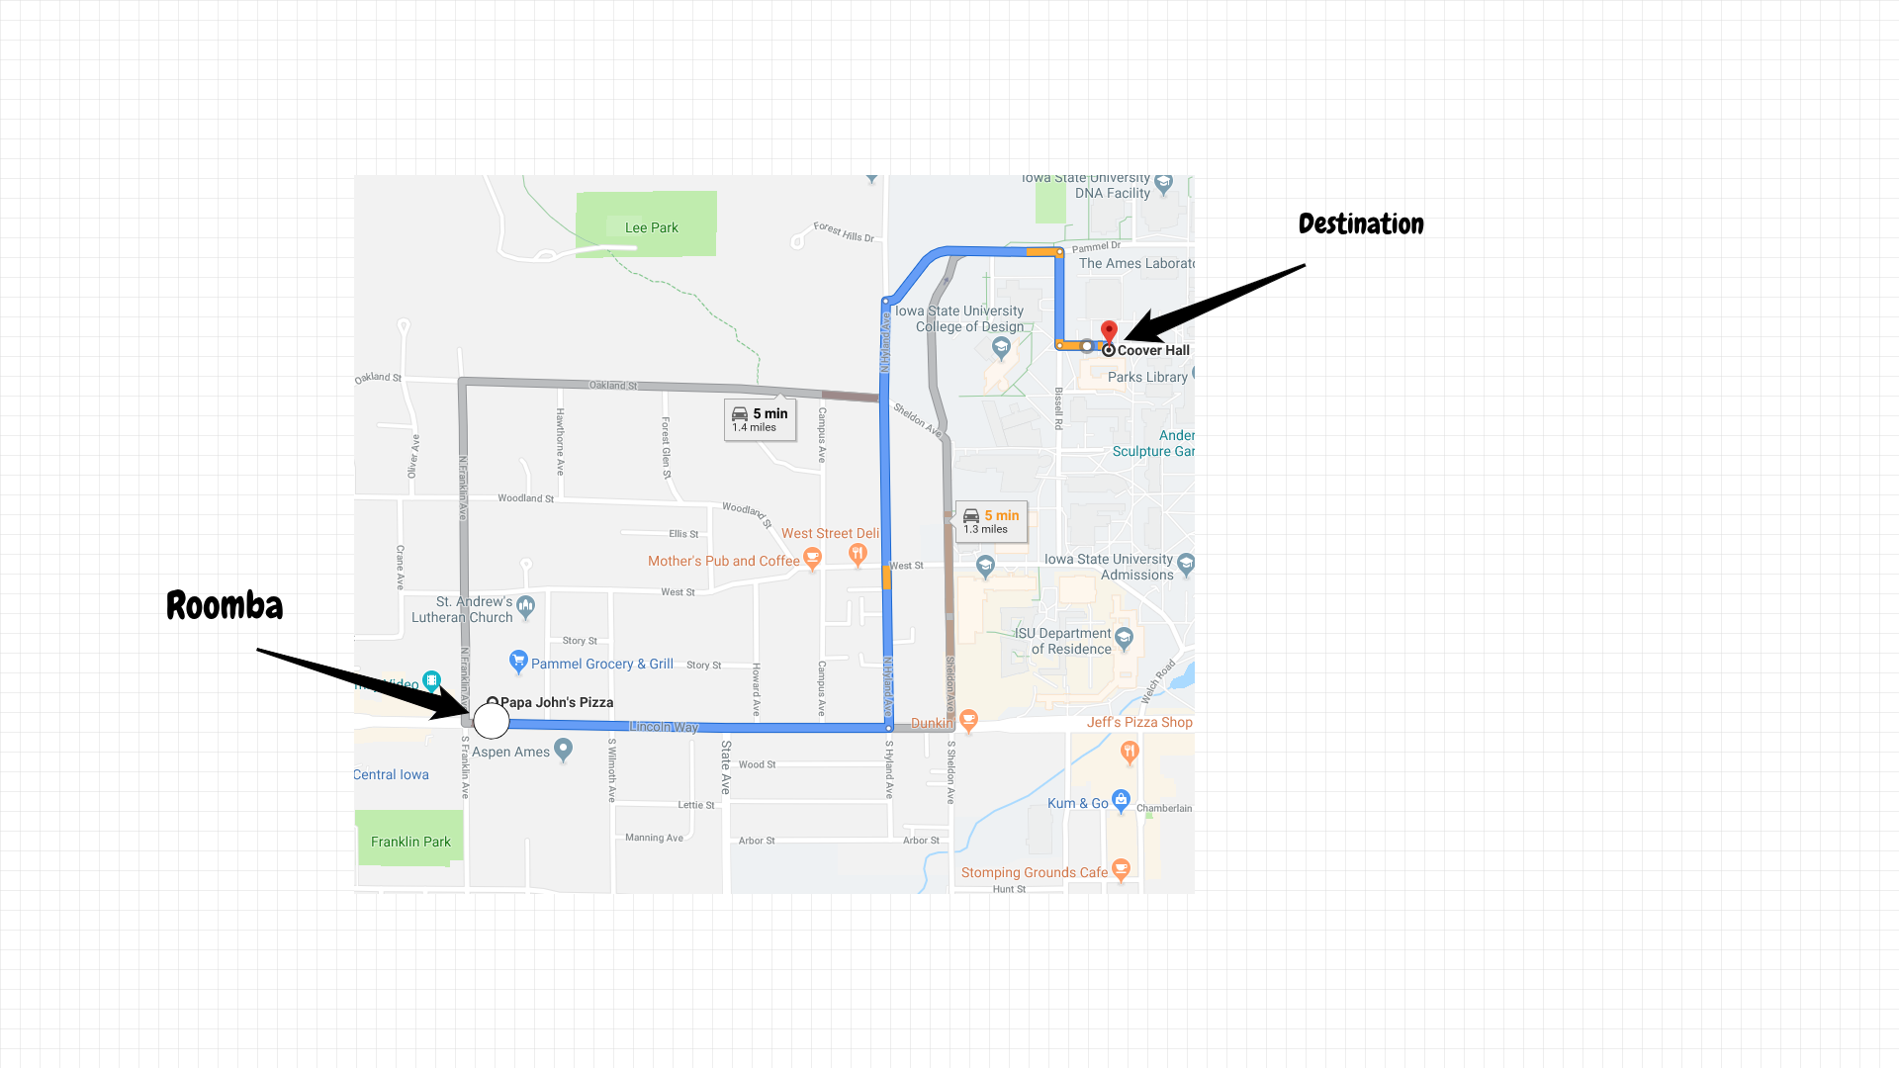

Problem sketch

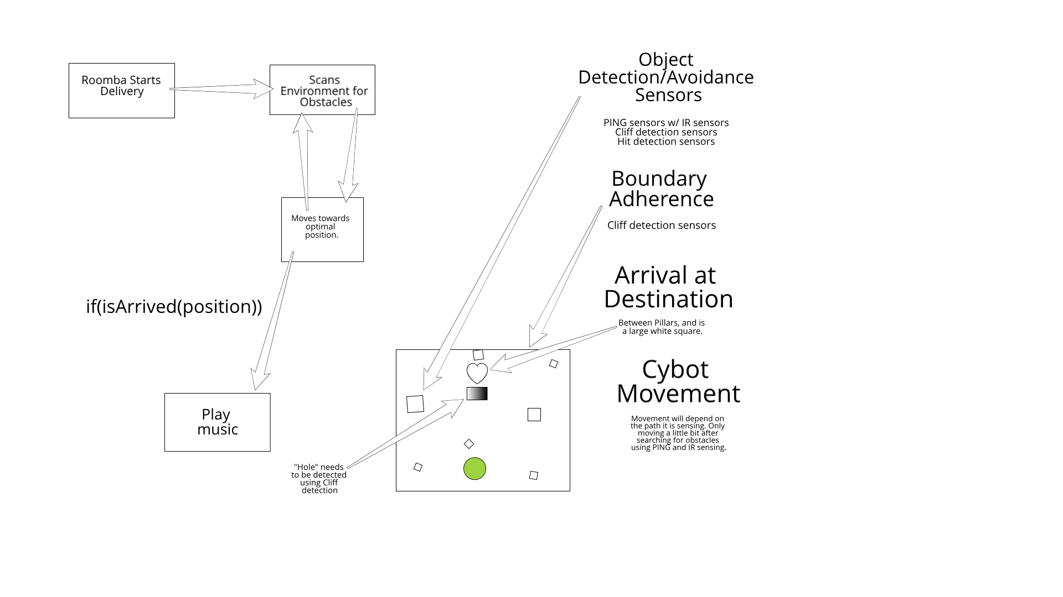

Technical system sketch